1. Login

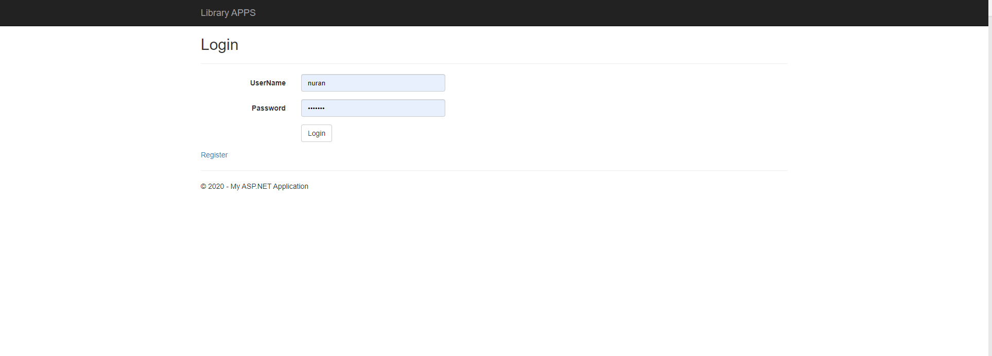

1. Admin
   1. Master User

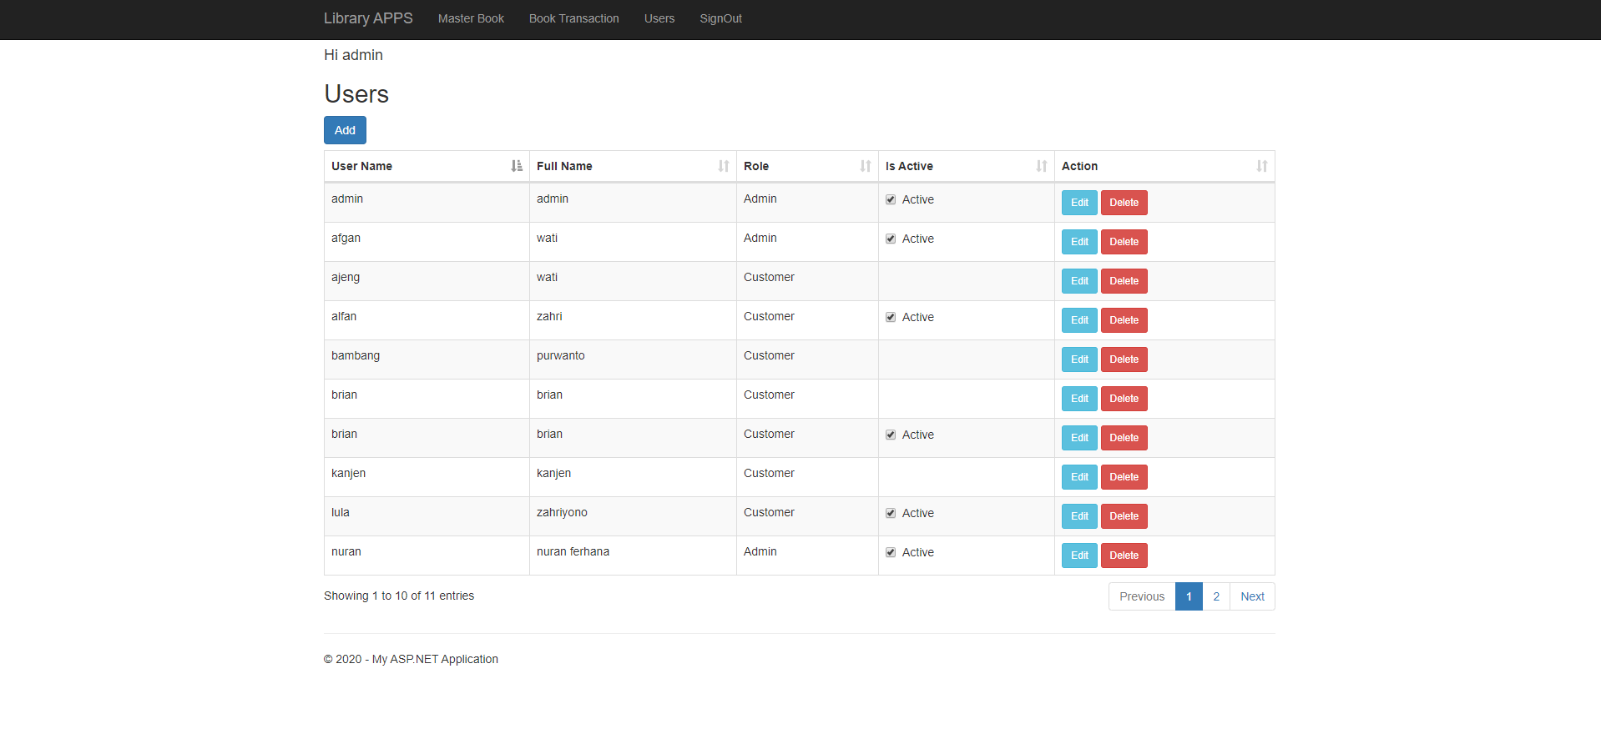

* 1. Add New user by Admin

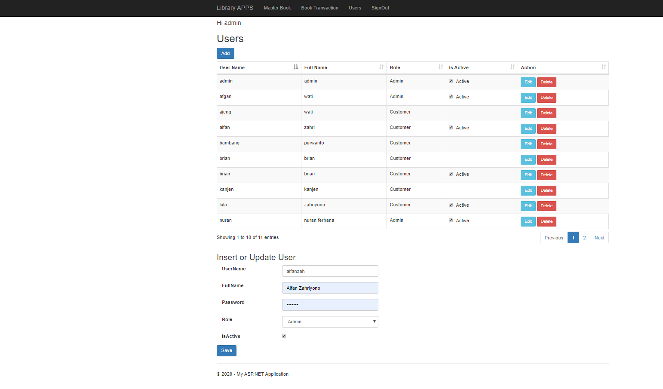

* 1. Transaction History

This view can be accessed by borrower and admin based on their roles. For admin not allowed to delete transaction and adding new transaction.

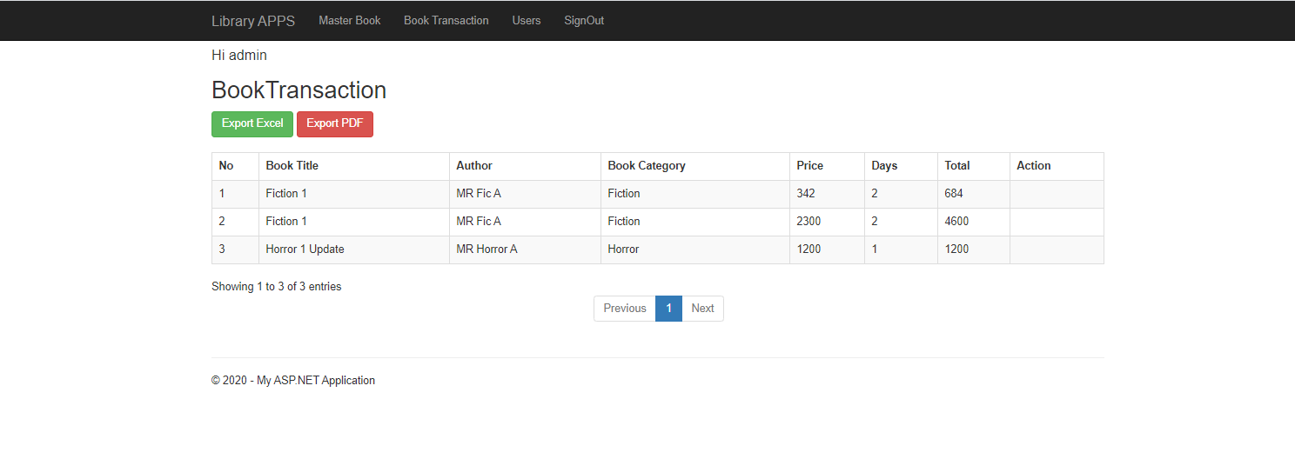

* 1. Master Book

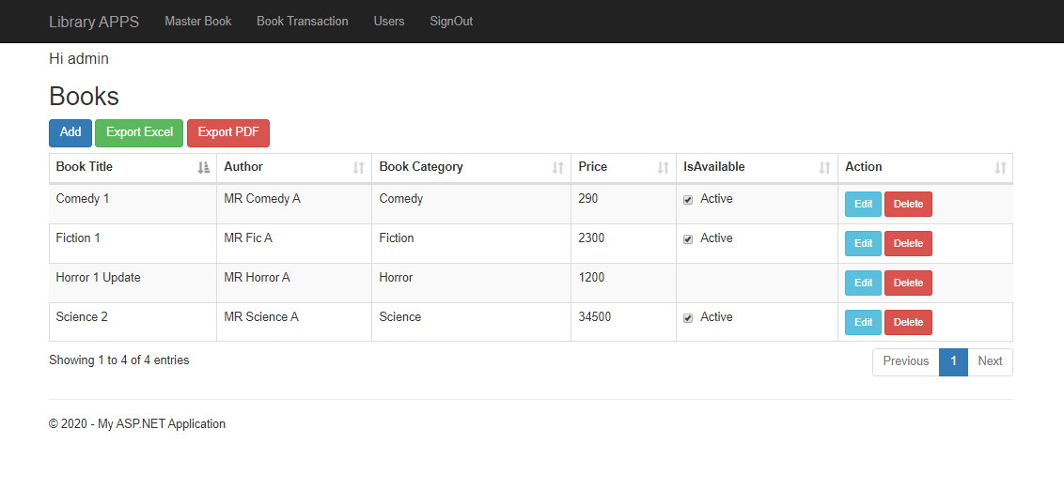

* 1. Add New Book

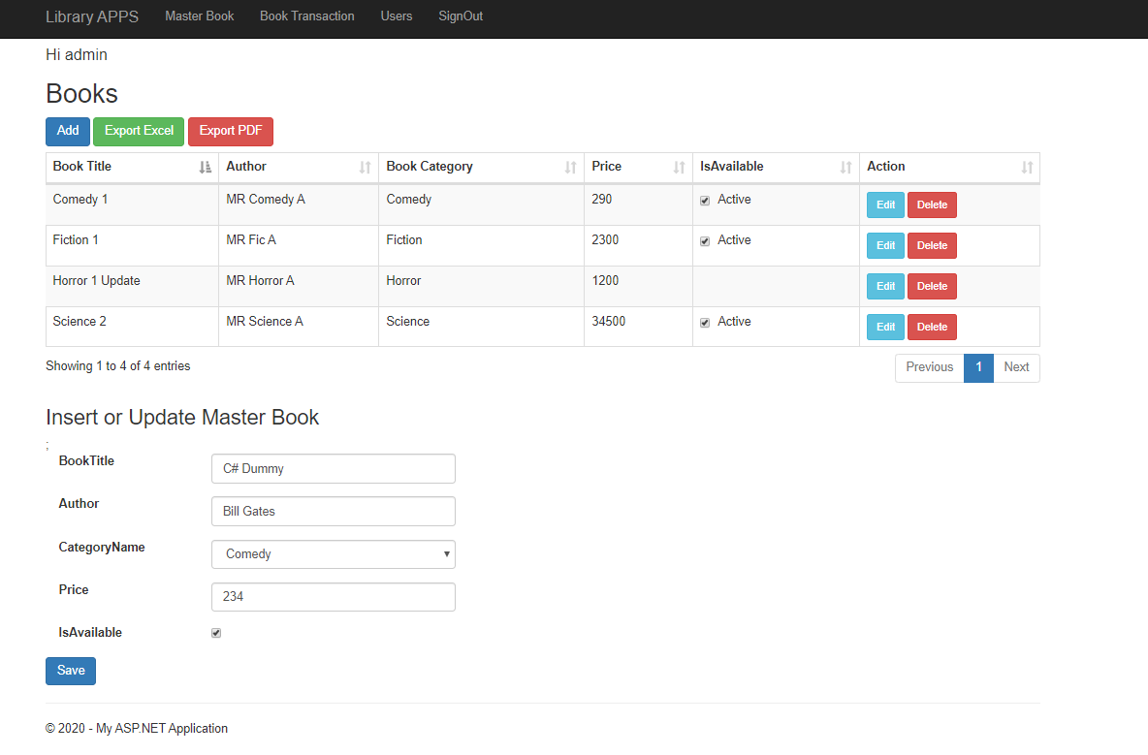

1. Register

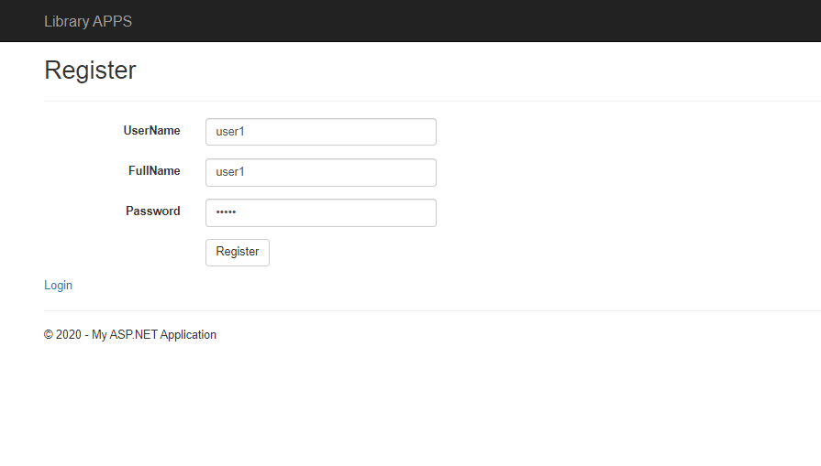

After registeration is done that administrator should activate

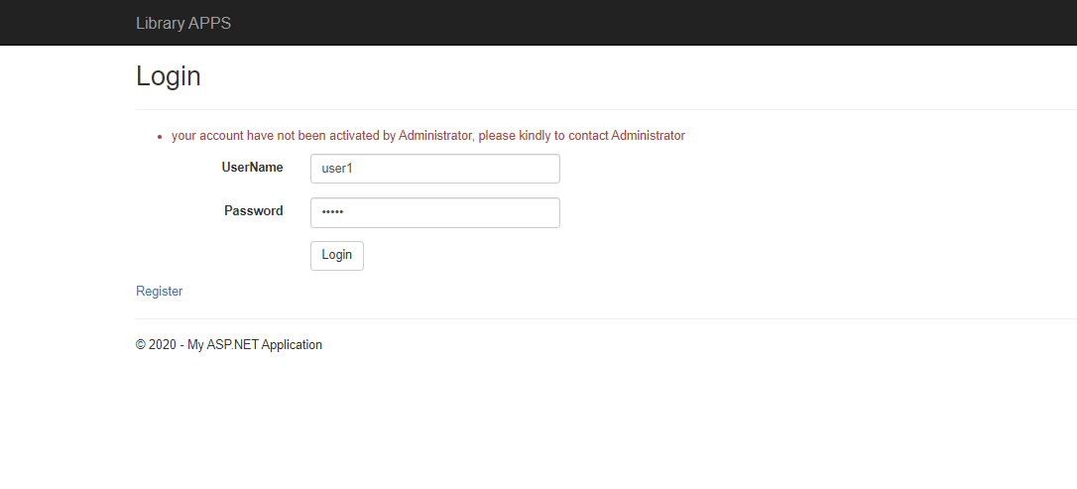

1. Borrower
   1. Transaction History

This transaction history only shown that created by user login.

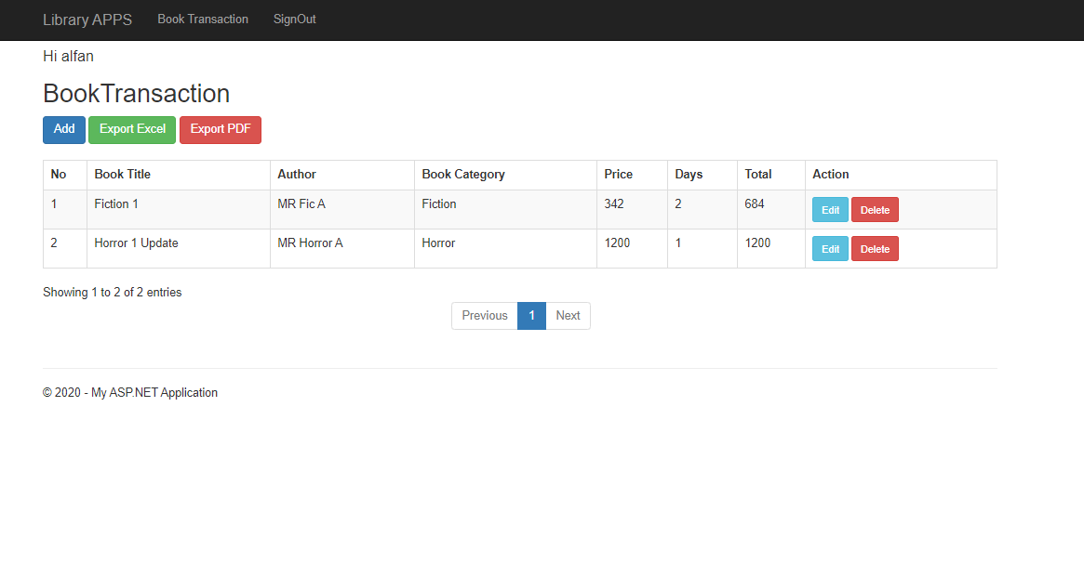

* 1. Add New Transaction

Data criteria that able to be saved:

* Book title required(when the book title is selected the other columns like Author,categoryname and price filled automatically)
* End date should be greater than startdate
* Before save, user must click calculate to get total price

